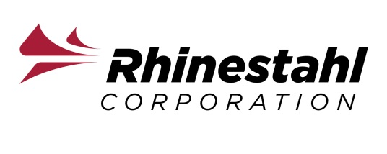
Fall Marketing Communications CO-OP/intern

JOB SUMMARY & RESPONSIBILITIES
- Write copy for collateral materials / literature, i.e. brochures, sell sheets, websites, etc.
- Capture high-quality, marketing-use-ready images of products.
- Develop PowerPoint presentations – with imagery and copy
- Manage social media accounts and build / execute content
- Write, build and execute email marketing newsletters and campaigns via Campaign Monitor software
- Build and deploy new web updates and content via Ample Proprietary CMS software
- Develop and execute customer and other surveys via Survey Monkey
- Coordinate trade show and other events, conferences and meeting logistics
Qualifications and Experience
- Marketing, Communications, Graphic Design or English student in 3rd or 4th year of study pursuing a Bachelor’s Degree
- Proficient in Microsoft PowerPoint, Excel, and Word
- Comfortable working with a camera
- Demonstrated ability to write for various media, especially print and digital
- Some experience with digital marketing, i.e. web, social media, email campaigns
- Experience marketing technical products a plus
- Energizing, enthusiastic, “can-do” attitude
- “Out of the box” thinking
- Collaborative and inclusive working style
- Strong verbal and written communication skills
- Highest standards of integrity, loyalty, honesty, moral and ethical values
- Organizational and time management skills
- High attention to details and accuracy
- Ability to meet strict deadlines
- Ability to multi-task efficiently
- Capable of working as a team and individually

Since 1967, Rhinestahl has prided itself on its entrepreneurial and can-do culture. Today, we seek team members that are inclusive of diversity of thought and style to bring the best ideas forward to delight the customer and achieve operational excellence. Rhinestahl is experiencing significant organic growth and is looking to add incoming talent to “Provide the Better Solution” to its customers now and well into the future. Rhinestahl is proud to be recognized by the Cincinnati Business Courier as one of the fastest growing 55 companies in Greater Cincinnati as well as named to the Deloitte Cincinnati Top 100 Private Companies. Equal Opportunity/Affirmative Action Employer M/F/Vets/Disabled. Candidates must be able to pass a background check and drug test.

Please email resumes to: Vickie Mc Mullen; Email Address: vickie.mcmullen@rhinestahl.com

