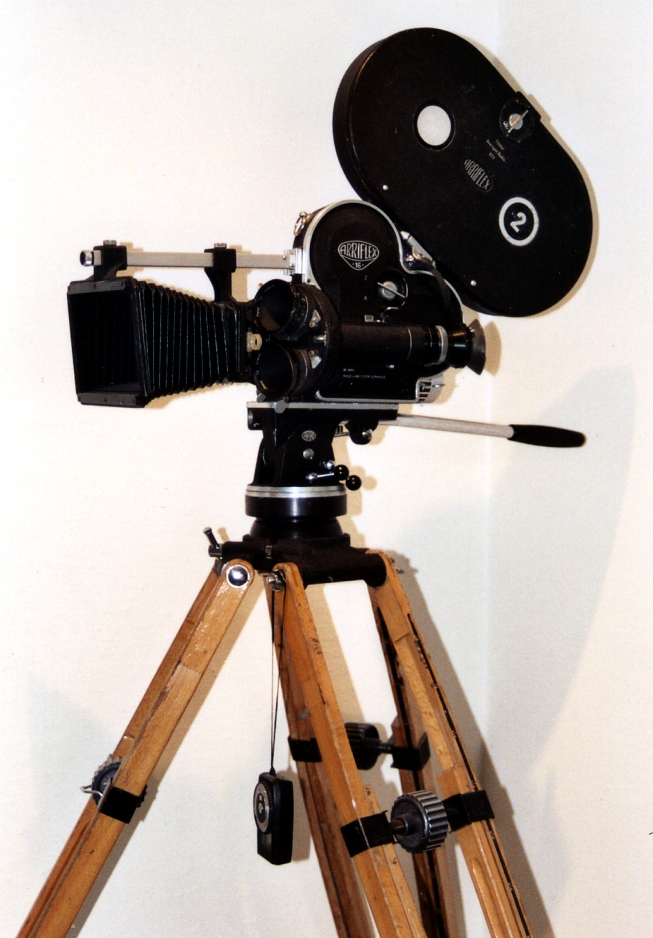
MAC 414B (4 Credits): SPRING Term 2017
CAPSTONE PICTURES
Mon & Wed 10:00-11:50 123 Williams Hall

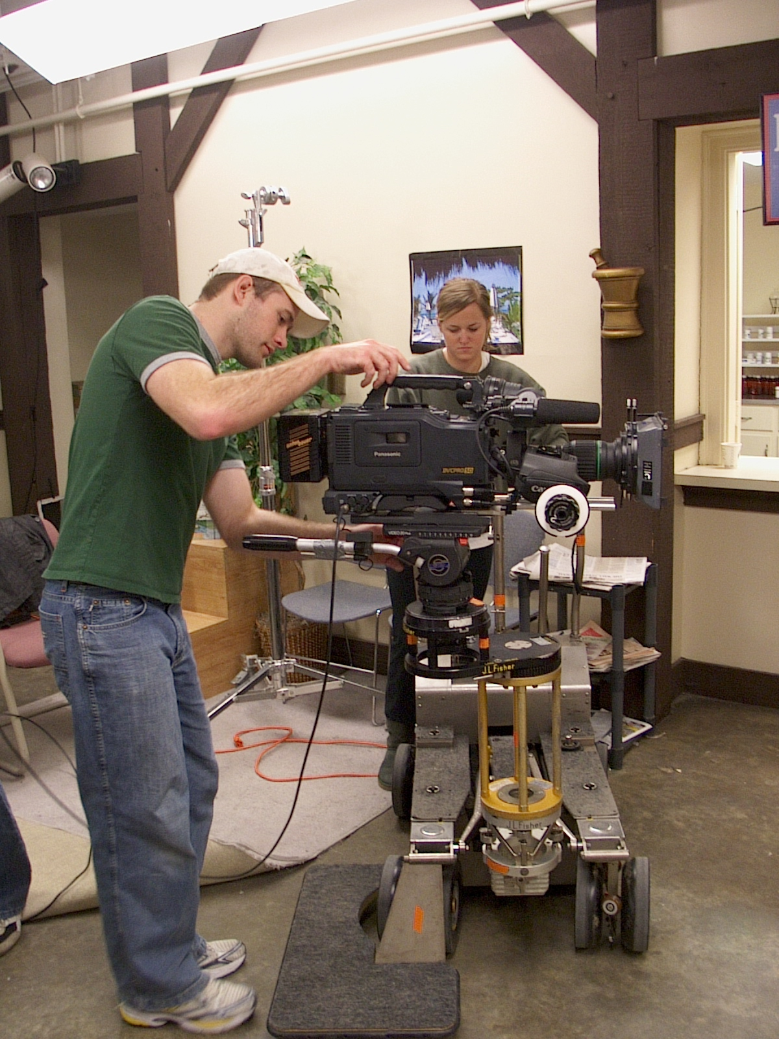

The primary goal of MAC 414B, a FILM PRODUCITON capstone course, is to produce a short narrative film. Students from all majors are encouraged to apply. The final digital filmwill be written, planned, directed, produced and edited by students.
The production process will be facilitated by faculty and professionals, who will offer advice and technical assistance to the students.

Instructor Permission Required. Questions or do get an application form: Contact Dr. David Sholle, Media, Journalism and Film, 513.529.3546 Sholled@miamiOH.edu

